ProPhoenix Installation Dashboard
Step-by-Step Installation Guide
Prepared by: Gobinath R, Installation Engineer
Date: March 04, 2026

1. Overview
This document consolidates the ProPhoenix Installation Dashboard steps into an operational, step-by-step guide with screenshots. It covers downloading the Installation Master Tool, loading the Master Zip, and executing DBSync, RMS PD Hotfix, CAD PD Hotfix, and Test/Demo Hotfix workflows.

2. Prerequisites
- Windows administrator privileges on the target servers (Web/App/SQL).
- Ability to run .EXE/.BAT or PowerShell scripts (.PS1). If certain file types are blocked by policy, use one of the alternates provided.
- Network access to either Azure Blob storage or Google Drive (Blob URL Permission only provided by the Cloud Team for the Public IP).
- Sufficient disk space to download/extract the Master Zip and perform backups as needed.

3. Download and Prepare the Installation Master Tool

- Open a browser and paste the Azure Blob or Google Drive download link provided by ProPhoenix.
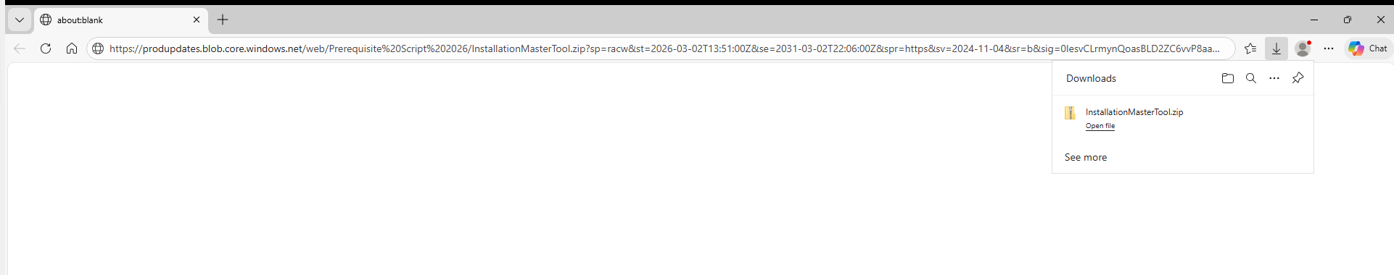
Paste the provided URL in the browser
2. Download the ZIP file to a local folder (e.g., C:\Downloads)
3. Open the download folder and extract the ZIP

4. Identify the three launcher formats available: .EXE, .PS1, and .BAT (use the one allowed in your environment).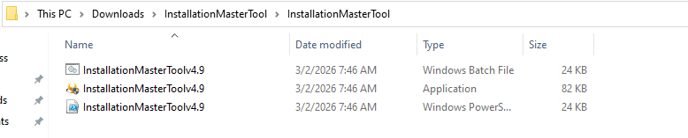5. Right-click each launcher → Properties → if you see a security warning, select **Unblock** → **Apply**.

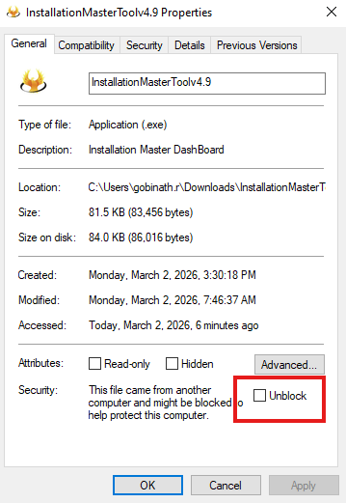

4. Launch the Installation Dashboard & Load the Master Zip

- Run the dashboard via .EXE, .PS1, or .BAT.
- If the prompt shows **No Valid Zip Found**, click **OK**.
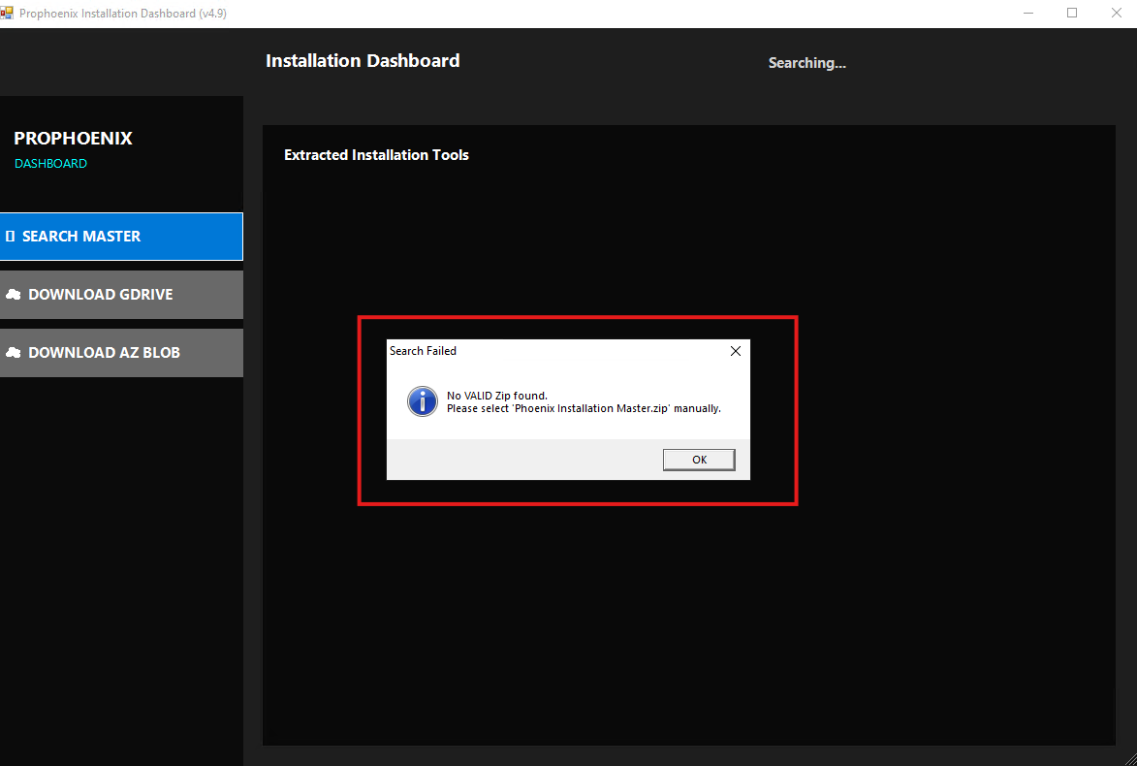
- Use **Download GDrive** or **AZ Blob** buttons to fetch the Master Zip (use the one accessible in your environment).

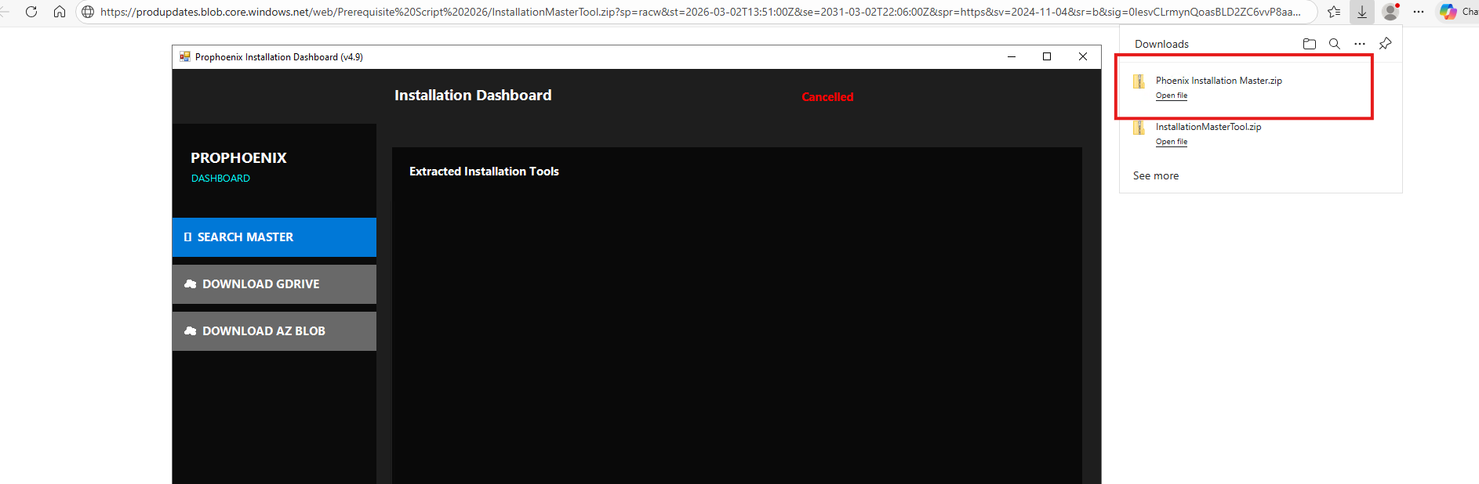
- Click **Search Master** and it will load the Tasks in the Dashboard
- Verify the status indicates **Master Loaded Successfully**.

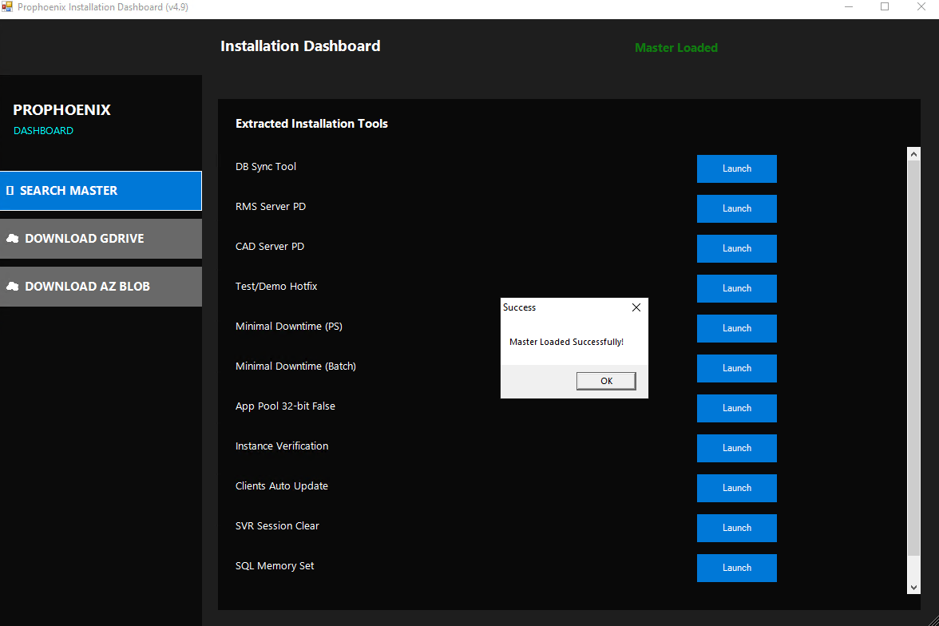

5. Scripts Available in the Dashboard

- DBSync Tool – Automated DB sync for Live/Test; utility install/uninstall; DB version check.
- RMS Server PD – Production RMS hotfix with minimal downtime (~20 minutes).
- CAD Server PD – CAD update (~10 minutes) with auto client update.
- Test/Demo Hotfix – Automated update for non-production environments.
- Minimal Downtime (PS & Batch) – Reduces service downtime for RMS updates.
- App Pool 32-bit False – Sets IIS App Pool “Enable 32‑Bit Applications” to **False**.
- Instance Verification – Ensures Base vs Instance DLL/file parity.
- Clients Auto Update – Opens client stages to trigger updates.
- SVR Session Clear – Clears CAD instance session files.
- SQL Memory Setting – Sets SQL Server max memory to 75% of RAM.

6. DBSync Tool — Run on SQL Server

- Launch the DBSync Tool on the **SQL Server**.
2. Enter the Required Credentials of the **SQL Server**.
3. Uncheck **Auto DB Sync** to manually select target databases if necessary.
- Connect to list available databases: Live, Training, Test, and Phoenix Master.
- Live Environment: the tool will uninstall/reinstall DB Utility and sync Live, Training, and Phoenix Master DBs automatically.
- Test Environment: the tool will uninstall/reinstall DB Utility and sync Test and Phoenix Master DBs automatically.
- Use **Check DB Version** to validate versions.
- Optional features in progress: Live→Test/Train DB copy; backup/restore automation.
DBSync UI overview
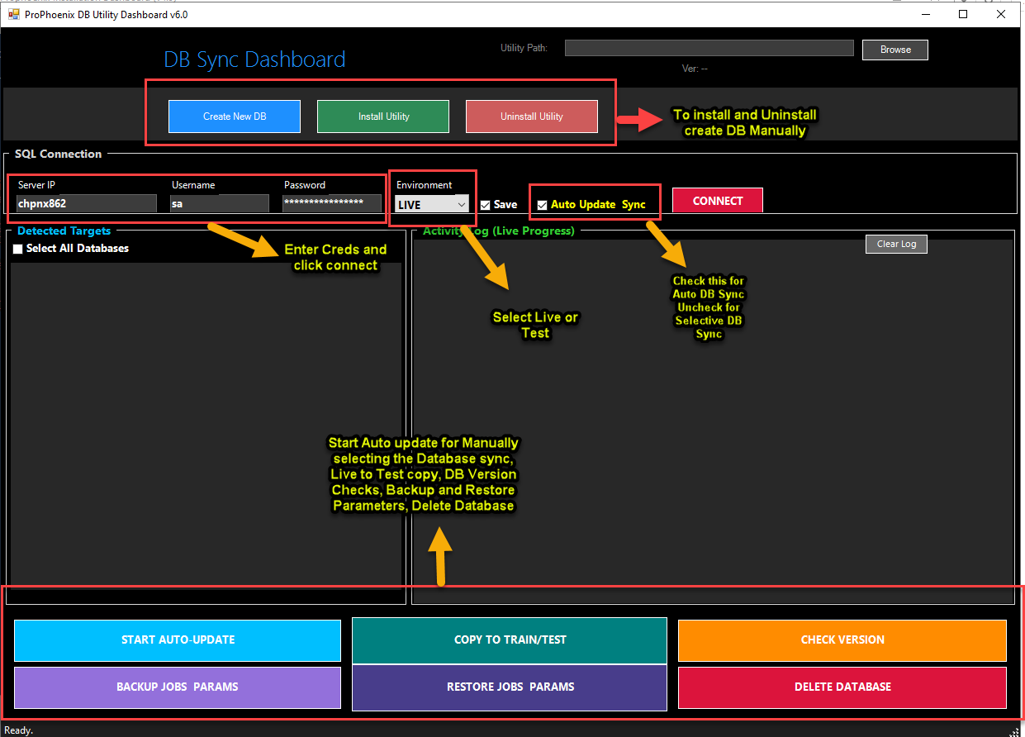

Manual selection of databases
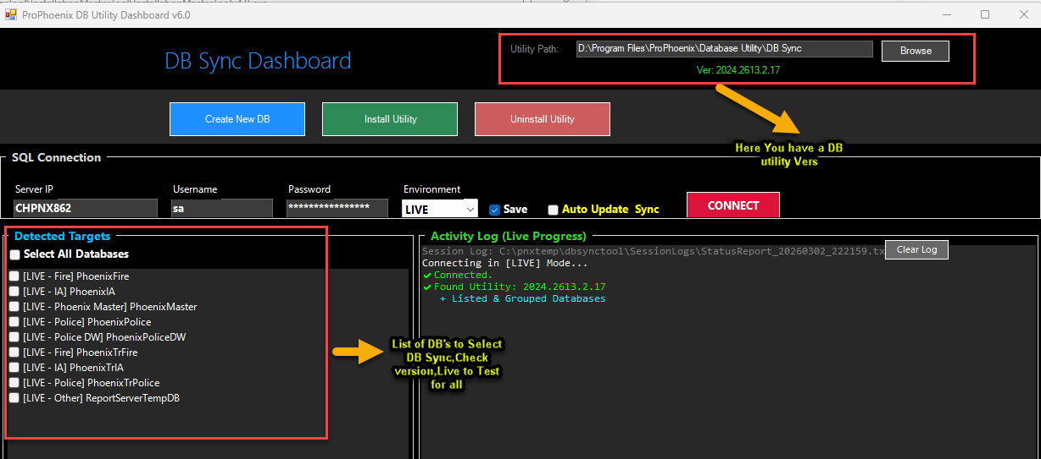
Live environment sync in progress
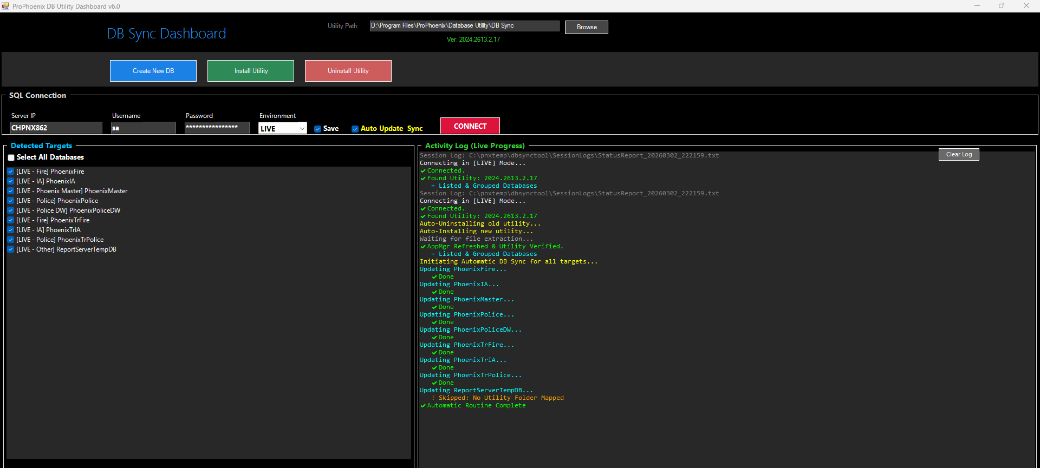
Test environment sync in progress
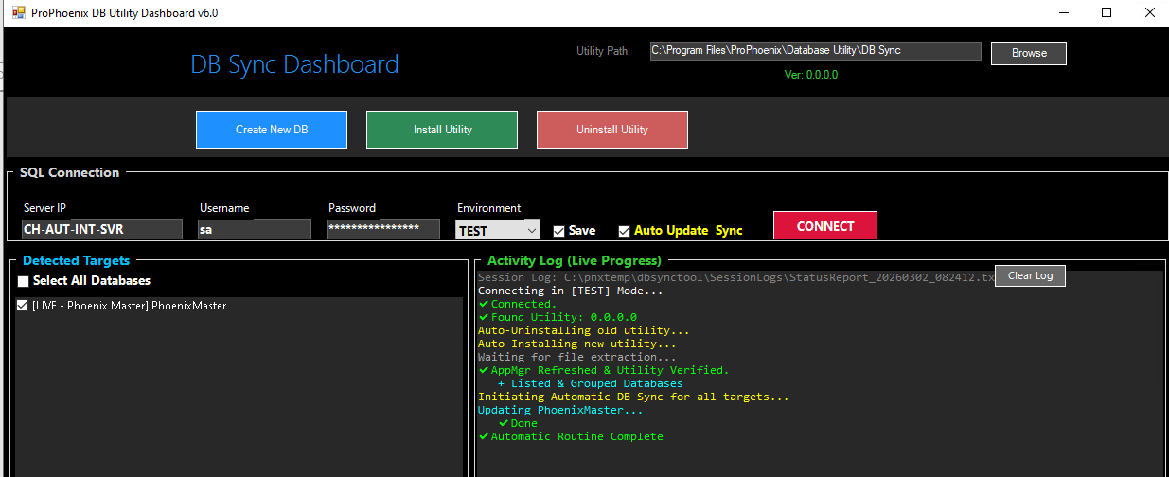

7. RMS Production (PD) Hotfix — Minimal Downtime (~20 minutes)

- Run the **Minimal Downtime** script for RMS first.
- It will find the List of RMS applications in the ProPhoenix Folder and Make a Copy to the Same Location and updated in the App Reg Main to the New Folder and Initiate the Bat File for the RMS Products
- Launch **RMS Server PD** and Enter
- It will generate the Automation bat file and At the product list prompt, press **Y** to proceed.
- The tool updates **Application Manager** and installs **General Applications** without stopping services.
- When prompted for Webservice, StageClient, PDF Service, and ReportWriter API, allow IIS and Phoenix services to stop proceeding.
- After installations, IIS restarts and **Instance Update** continues automatically.
- Once Instance Update completes, services restart and running status is displayed.
- Run **Instance Verification** to validate Base vs Instance parity.
- Client stages open for **Clients Auto Update** (Feature for all-in-one servers).
- Optionally accept prompts to update **Help Docs** and **Hazmat Guide**.

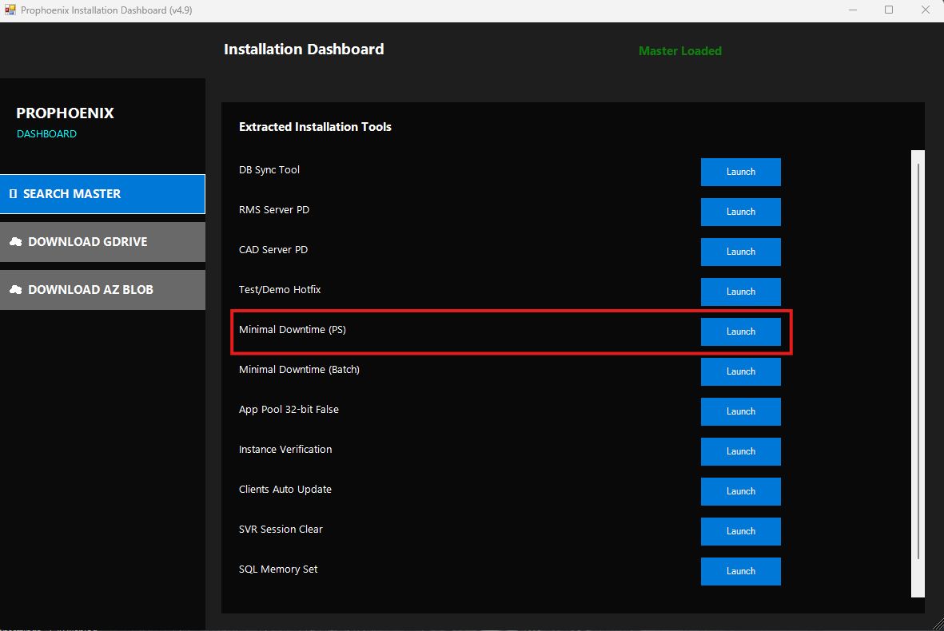

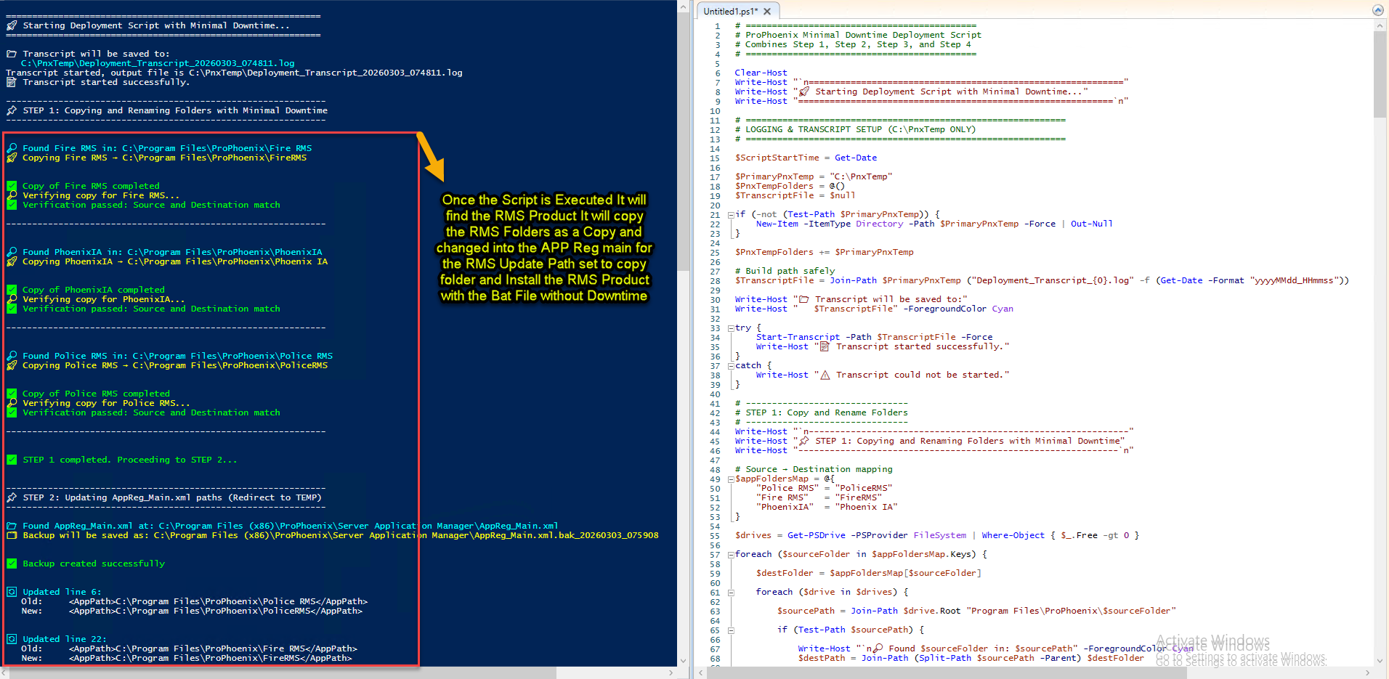
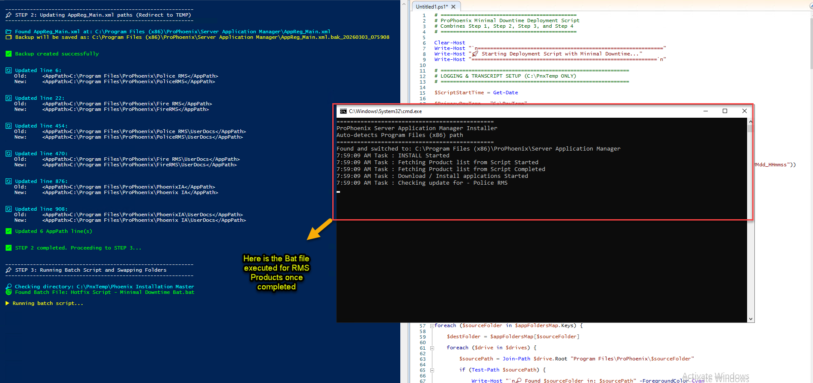

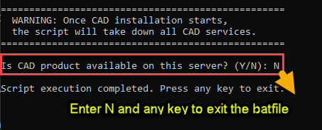
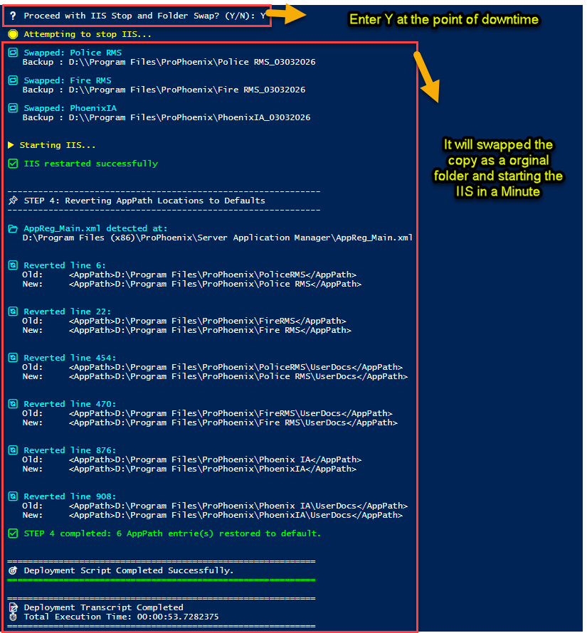
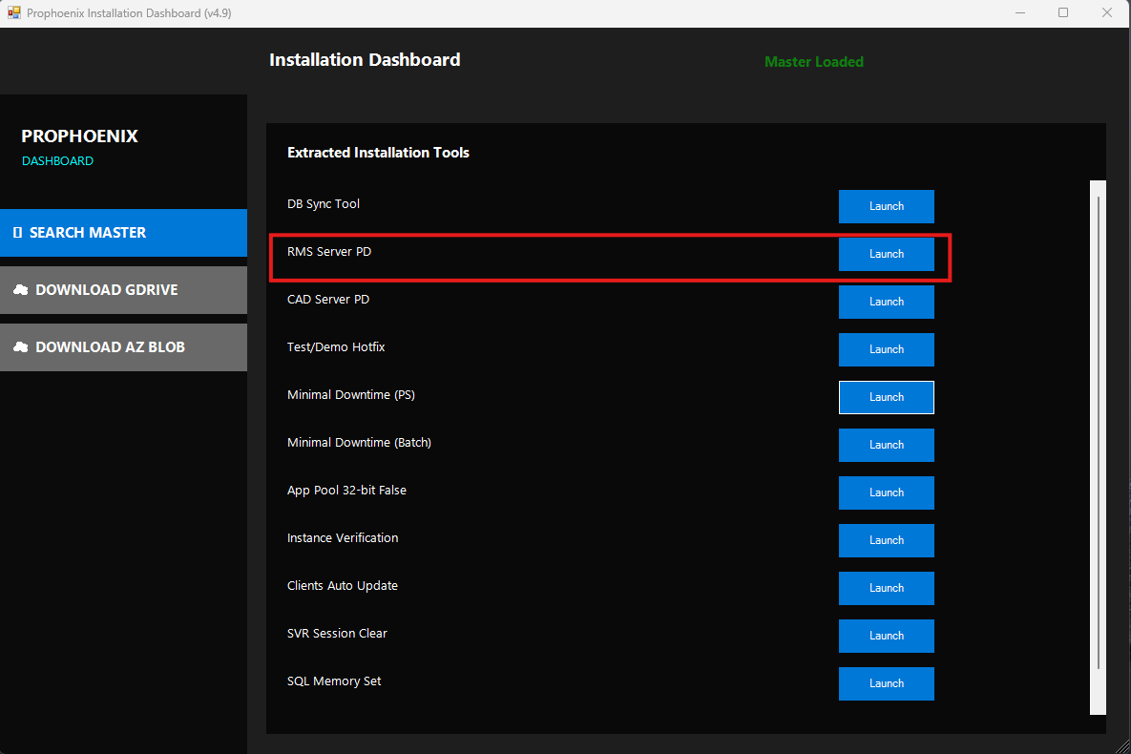
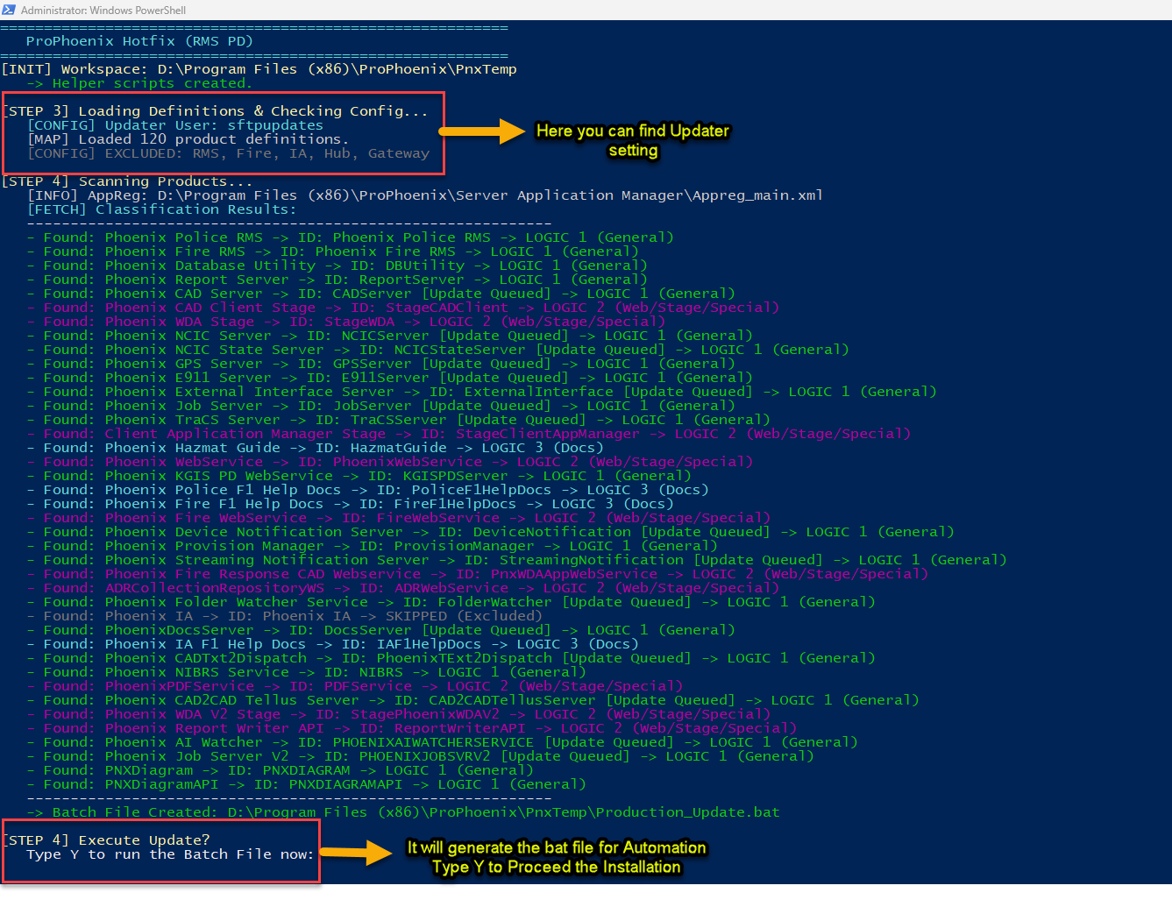
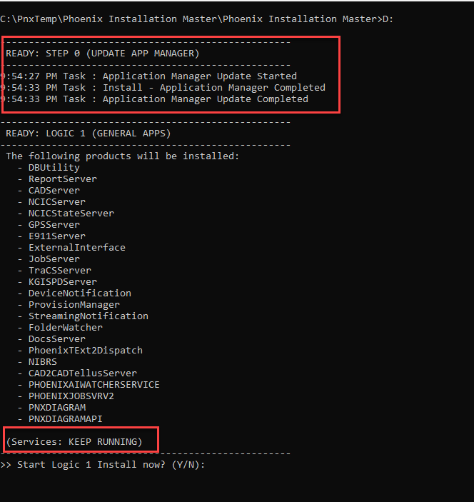
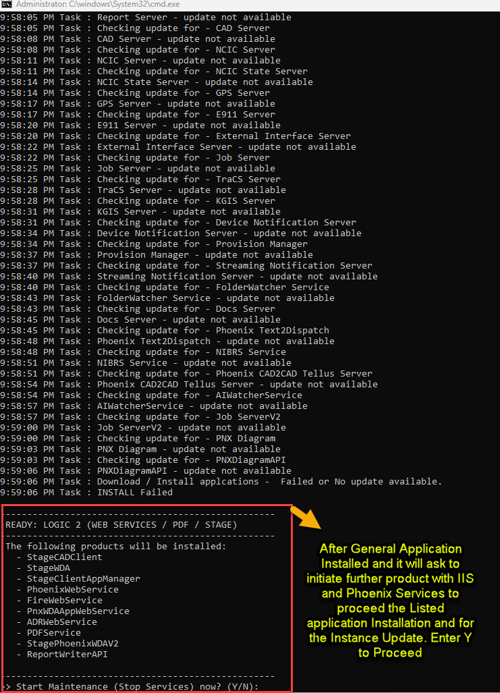
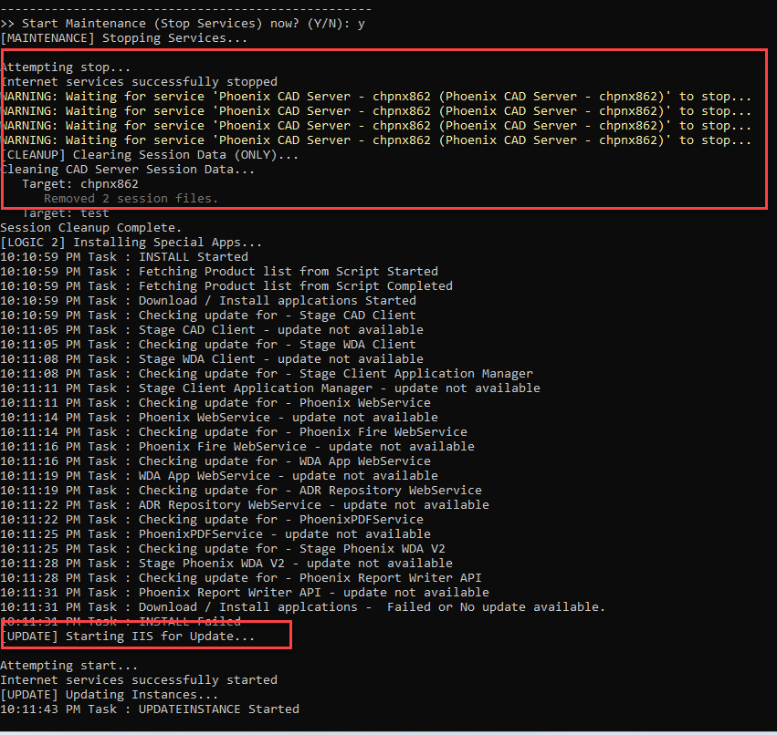
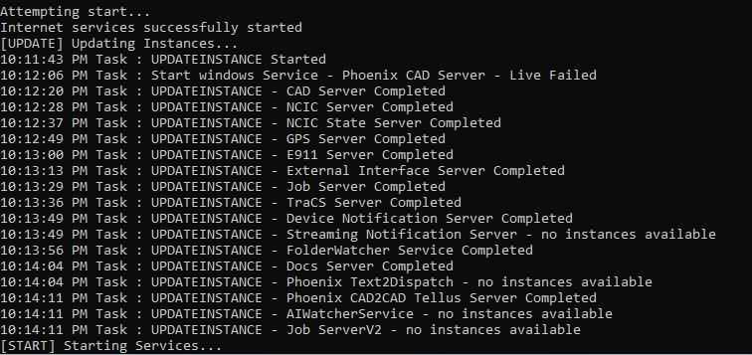
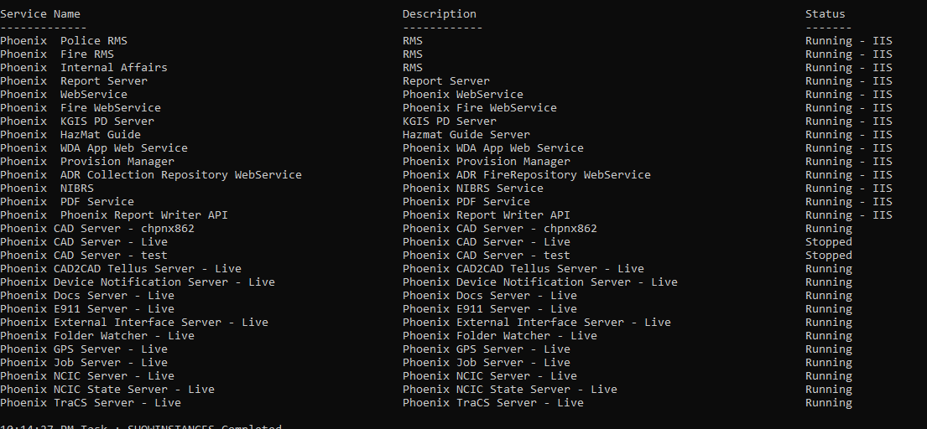
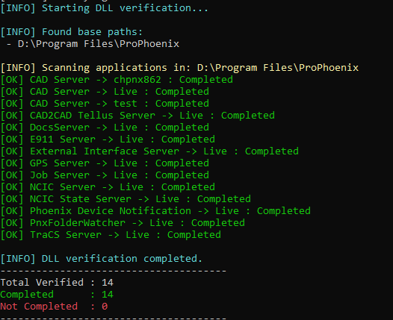
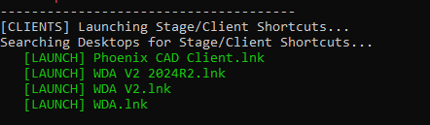
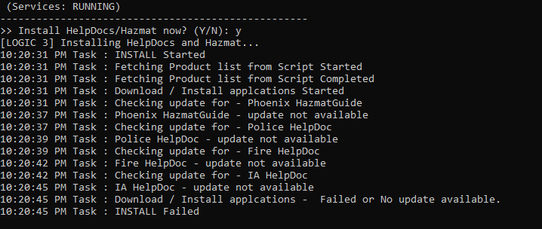

8. CAD Production (PD) Hotfix — ~10 - 15 Minutes

- Launch **CAD Server PD**.
- At the product list prompt, press **Y** to proceed.
- Update **Application Manager** and install **General Applications** (no service stops required).
- At the scheduled time, proceed with **Stage Clients** installation and it will stop IIS and Phoenix Services
- The script runs **Instance Update**, clears **SVR Session** data, and performs **Log Clear**.
- Verify completion status, then press any key to start **Clients Auto Update**.

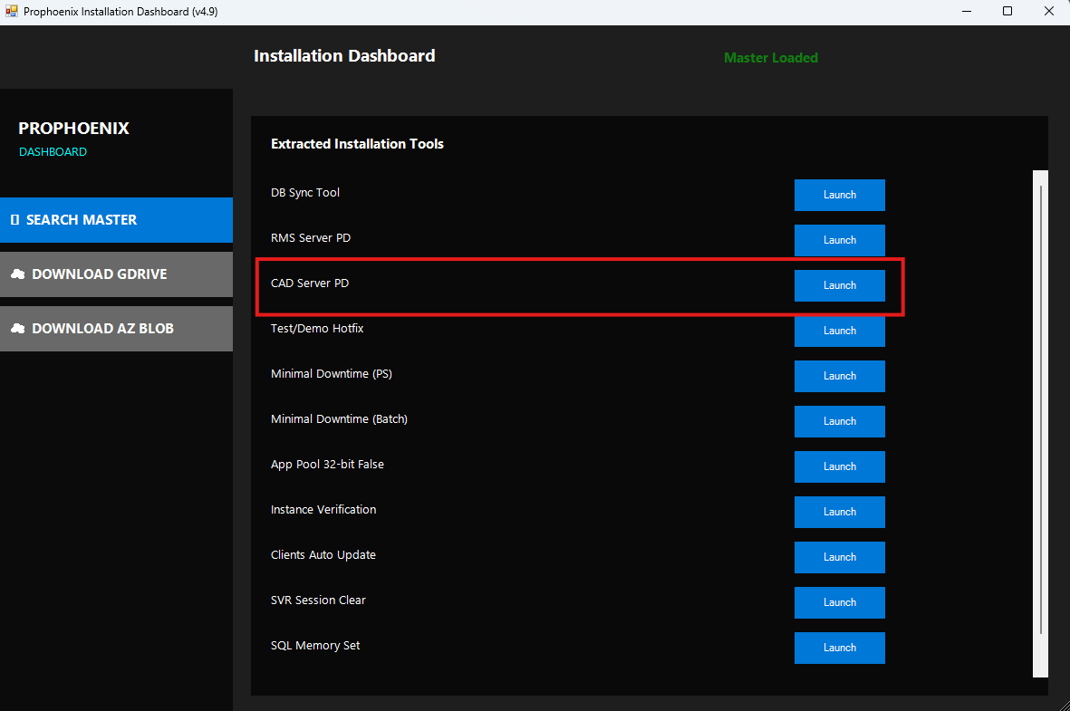
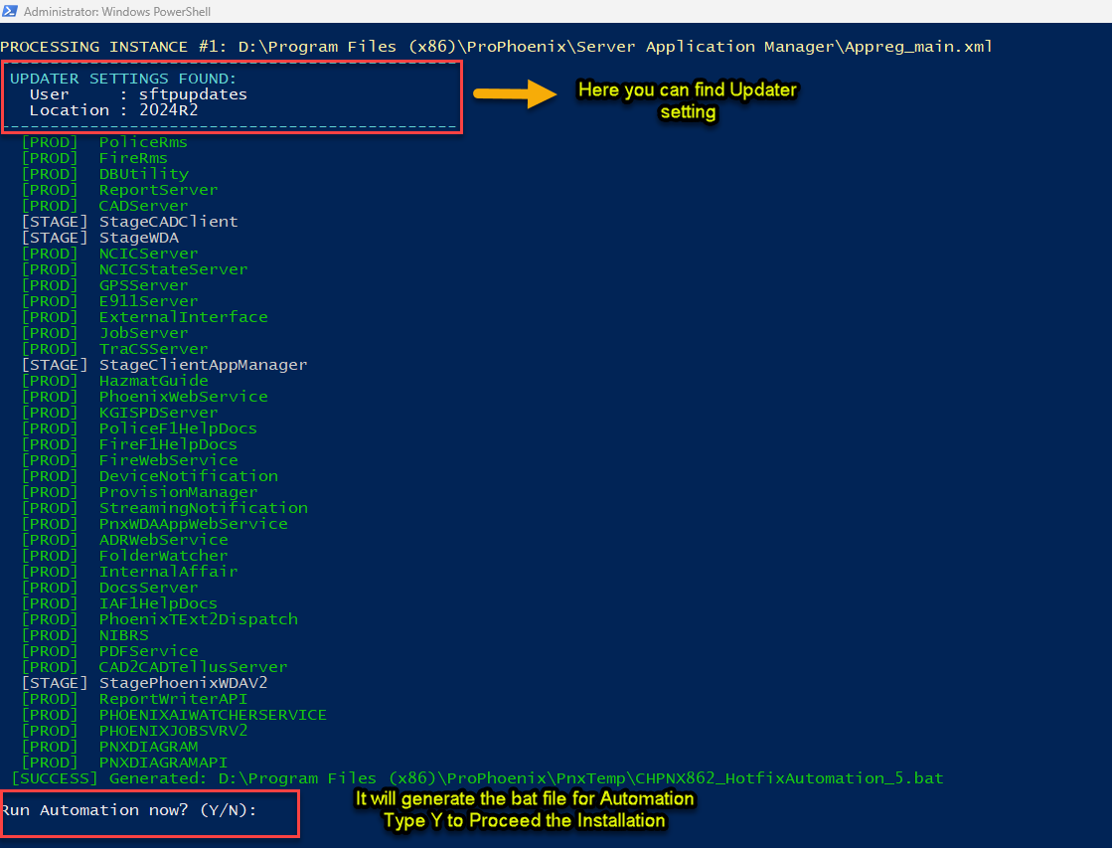
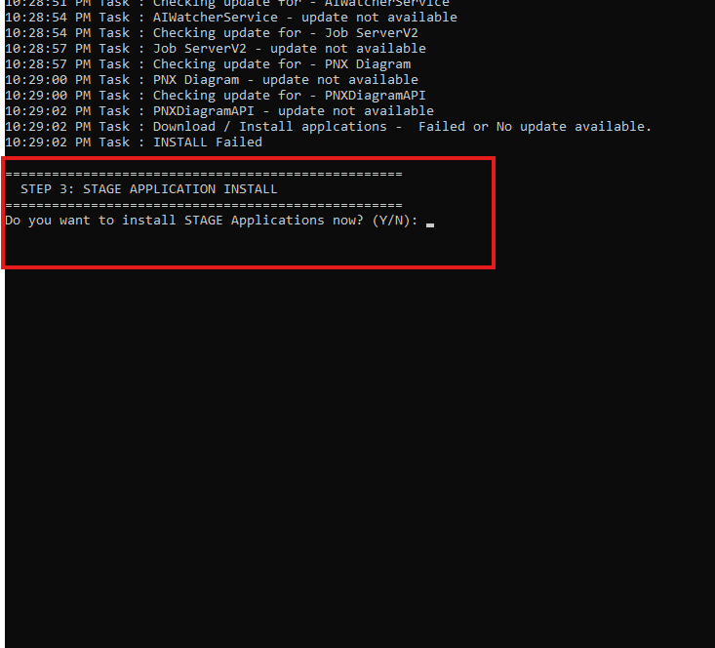
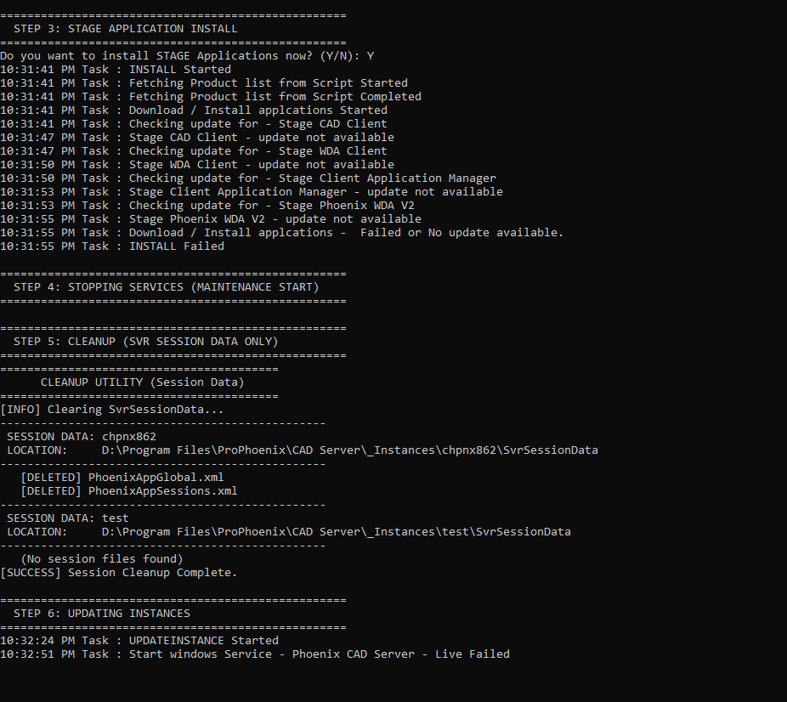
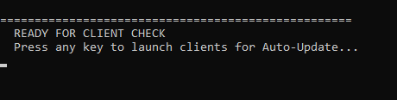

9. Test/Demo Hotfix — Non-Production
- Launch **Test/Demo Hotfix**.
- Review updater settings and product list; press **Y** to start the automation.
- The script updates Application Manager and installs all applications, stopping IIS and instances when needed.
- Instance Update and **Verification** run automatically.
- Press any key when prompted to trigger **Clients Auto Update**.

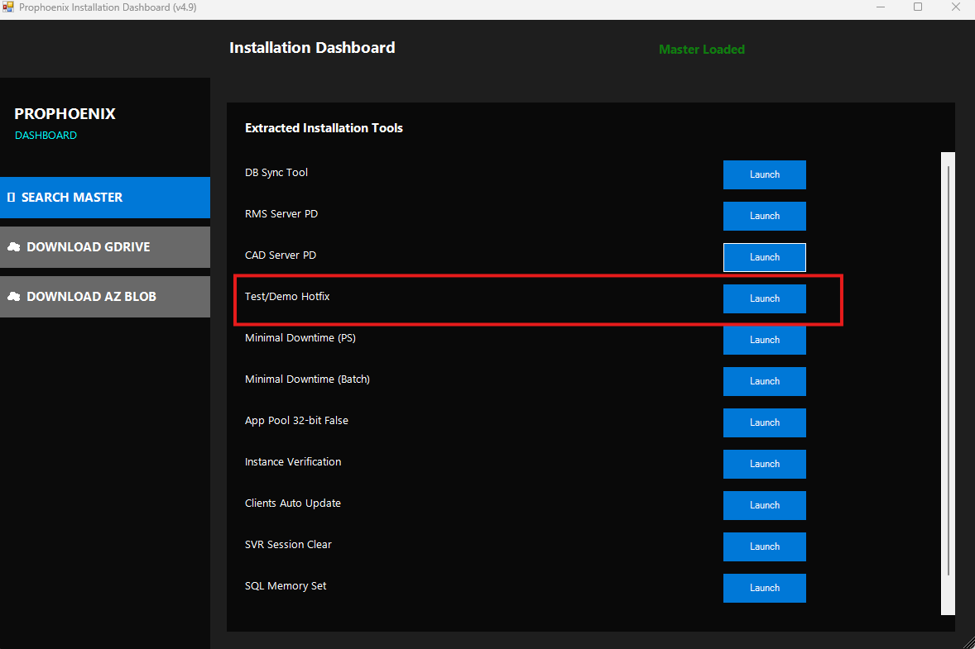
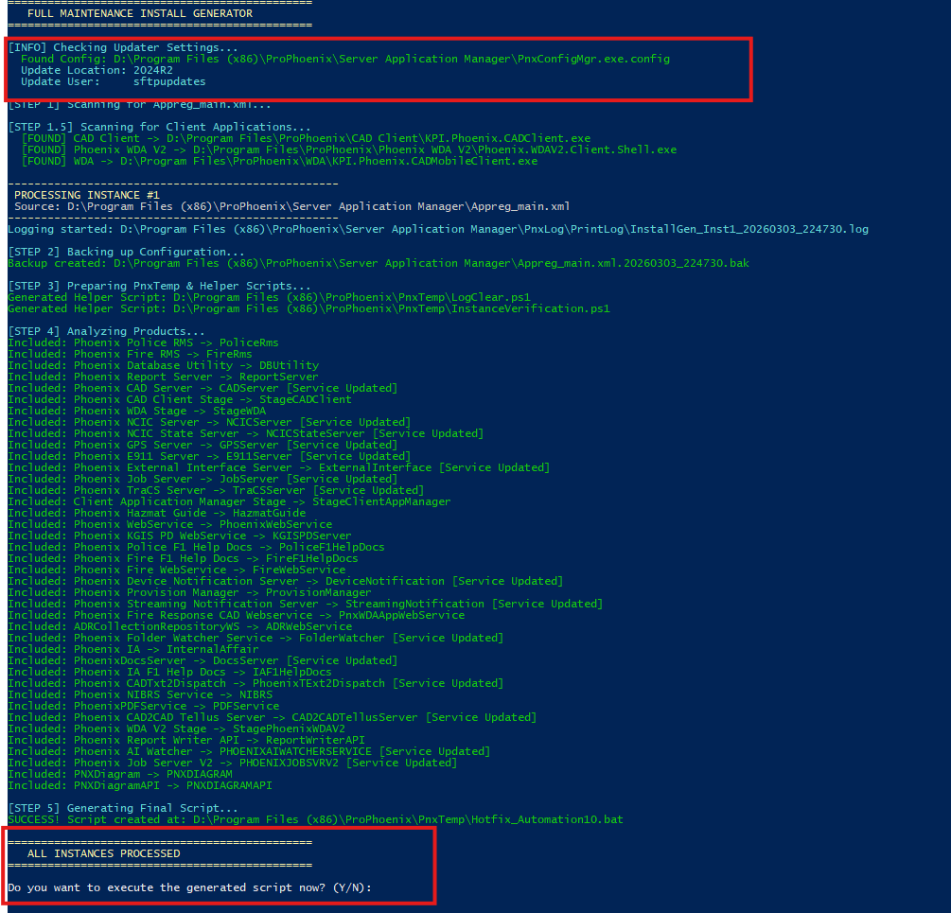
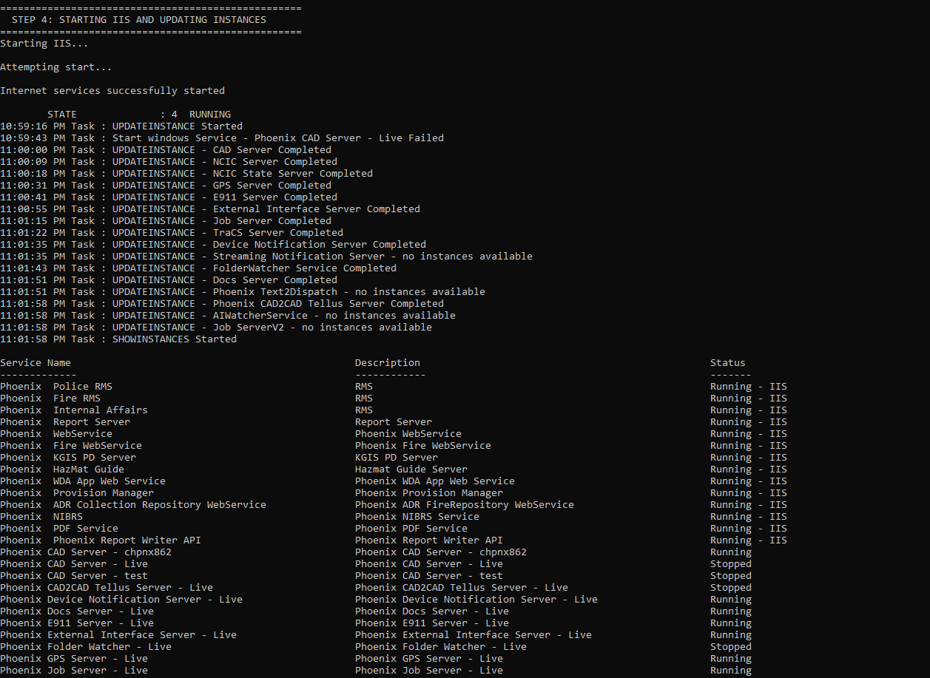
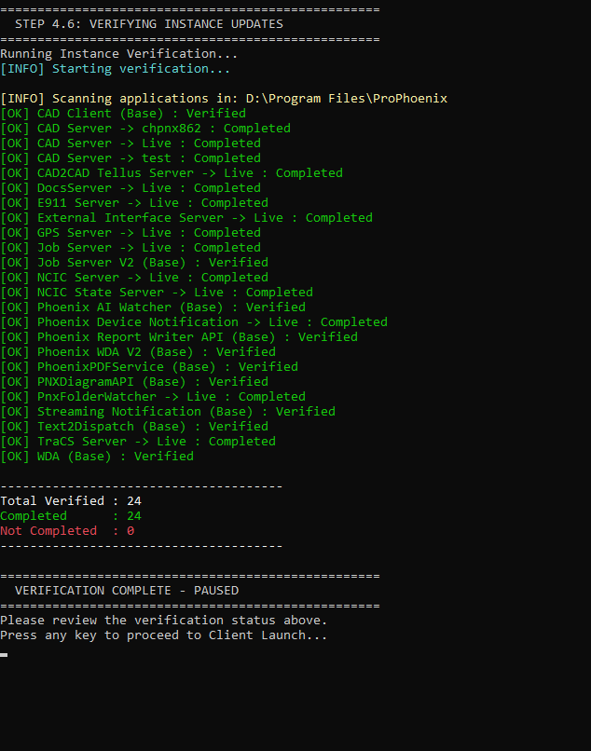

10. Post-Install Checks & Validation
- Confirm all services are **Running** (IIS sites/app pools; Phoenix services).
- Perform Pre - compiler: login and Verify the application Working
- Review **Instance Verification** results for parity.
- Ensure IIS App Pool **Enable 32‑Bit Applications = False** where required.
- On SQL Server, verify **Max Server Memory ≈ 75% of RAM**.
- Run **Log Cleaner** after collecting any necessary diagnostics.

